

STUDENT CASE STUDY EXECUTION REPORT

Department | FED
Subject | DSA-2
Academic Year | I-III Semester (2025-26)
Faculty Name | Balaiah G
Student Name | I.Vikram
Roll Number | 2520090118
Branch | CSIT
Course Outcome | Analyze and Implement Dijkstra's,Bellman-Ford, and Floyd-Warshall shortest-path algorithms
Case Study Topic: IRCTC fare-routing A* search — straight-line heuristic for early termination. Work Done Summary:
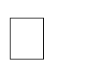










Constructed the railway network as a weighted graph with 8 stations and fare-based edges. Assigned heuristic values representing the estimated remaining cost from each station to Kolkata. Initialized the A* search algorithm from Mumbai (MUM).
Used a priority queue to select the station with the minimum estimated total cost 𝑓(𝑣) = 𝑔(𝑣) + ℎ(𝑣). Expanded neighboring stations and updated path costs whenever a cheaper route was found.
Continued the search by exploring the most promising stations based on heuristic values. Reached the destination station (KOL) and terminated the search.
Reconstructed the optimal route using parent pointers. Calculated the minimum fare as ₹1000.
Obtained the optimal path MUM → NGP → RNC → KOL (an equally optimal path through PAT also exists). Demonstrated that A* explores fewer nodes than Dijkstra's algorithm due to heuristic-guided search.

Implementation Details: Create the Graph

- Represent stations as nodes and train fares as weighted edges. Store Heuristic Values

- Assign precomputed heuristic h(v) for each station. Initialize A*
- Set g(source) = 0.
- Calculate f(v) = g(v) + h(v).

- Insert source node into the priority queue. Select Best Node

- Remove the node with the smallest f(v) from the priority queue. Expand Neighbors
- Compute new cost:


- Update if a cheaper path is found. Update Priority Queue
- Insert neighbor with priority:
𝒈(neighbor) = 𝒈(current) + edge cost

𝒇(𝒗) = 𝒈(𝒗) + 𝒉(𝒗)


Check Goal

- If the extracted node is KOL, stop the search. Construct Path

- Use parent pointers to reconstruct the route from MUM to KOL. Display Result
- Print shortest path, total fare, and number of nodes explored.

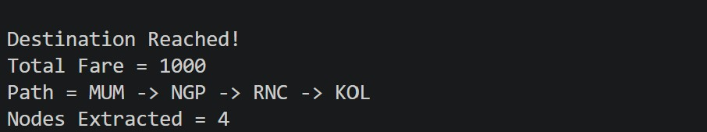
Result: Screenshots / Output
Result
- Optimal Fare: ₹1000
- Optimal Path: MUM → NGP → RNC → KOL
- Nodes Explored: 4
- Algorithm Used: A* Search with admissible heuristic.

